Zion Lutheran Church
9 a.m. Contemporary Worship
First Sunday in Advent
November 30, 2025
Scripture Readings
First Reading: Isaiah 2:1-5
Second Reading: Romans 13:11-14
Gospel Reading: Matthew 24:36-44

Altar Flowers
The altar flowers are given to the glory of God and in honor of the birthdays of Bre Bybel and Justin Kidwell.

Zion Prayer List 11-30-2025
The Family of Ann Iberg, Shirley Hyssong, Ronnie Kinna, The Yonge Family, Carrie Basler, Dennis McGinnis, John Hughes, Linda Kinna-Engel, Dave Gouker, Pat McIntosh, Richard Brandenburg, Ruth Brant, Vicki Ringwelski, Elsie Warnock, David Shupe, Meredith Kinna, George Engel, Jo Ahalt, Glenn Little, Sandy Bidle, Catherine Brown, Tristan Swiney, J. Richard Staples, All Government Workers, Pastor Diane Day, Beverly Smith, Dana Carmichael, The Gunsallus Family, Samn Huffer, Pat Hansen, Eric Kinna, Linda Stottlemyer, Anita, Gary, Bruce Albright, Marty Appleby, Judith Smith, Jackie Bello, Trish Tollefson, Addison Hopson, Kevin Kinna, Deb Kahihikolo

Deaths: Ann Iberg

Please note the updated Prayer List. If a name was removed you would like on, please let the Church Office know. Thank you! Please also be sure the church is notified if you are hospitalized and if you wish to be placed on the prayer list or would like visitation.

To give financially, please give either online or in the offering plate that the ushers will pass in between pews. You can also scan the QR code to be taken to our online giving portal.

Zion Lutheran Church
9 a.m. Contemporary Worship
First Sunday in Advent
November 30, 2025
Scripture Readings
First Reading: Isaiah 2:1-5
Second Reading: Romans 13:11-14
Gospel Reading: Matthew 24:36-44

Altar Flowers
The altar flowers are given to the glory of God and in honor of the birthdays of Bre Bybel and Justin Kidwell.

Zion Prayer List 11-30-2025
The Family of Ann Iberg, Shirley Hyssong, Ronnie Kinna, The Yonge Family, Carrie Basler, Dennis McGinnis, John Hughes, Linda Kinna-Engel, Dave Gouker, Pat McIntosh, Richard Brandenburg, Ruth Brant, Vicki Ringwelski, Elsie Warnock, David Shupe, Meredith Kinna, George Engel, Jo Ahalt, Glenn Little, Sandy Bidle, Catherine Brown, Tristan Swiney, J. Richard Staples, All Government Workers, Pastor Diane Day, Beverly Smith, Dana Carmichael, The Gunsallus Family, Samn Huffer, Pat Hansen, Eric Kinna, Linda Stottlemyer, Anita, Gary, Bruce Albright, Marty Appleby, Judith Smith, Jackie Bello, Trish Tollefson, Addison Hopson, Kevin Kinna, Deb Kahihikolo

Deaths: Ann Iberg
Please note the updated Prayer List. If a name was removed you would like on, please let the Church Office know. Thank you! Please also be sure the church is notified if you are hospitalized and if you wish to be placed on the prayer list or would like visitation.
To give financially, please give either online or in the offering plate that the ushers will pass in between pews. You can also scan the QR code to be taken to our online giving portal.

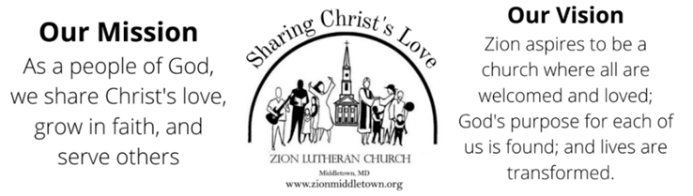
Phone: 301-371-6500; Website: www.zionmiddletown.org
For emergency pastoral care or to schedule an appointment, please call the church office
for additional information.
The Rev. Diane Day—Co-Pastor
ext. 202, pastordiane@zionmiddletown.org
The Rev. Matt Day—Co-Pastor
ext. 209, pastormatt@zionmiddletown.org
Deb Reichelt – Office Business Manager
treasurer@zionmiddletown.org
Kaye Derr-Financial Secretary
financialsecretary@zionmiddletown.org
Matt Puziss - Director Contemporary Worship Team
mattpuziss@gmail.com
Katelyn McClinton-Director of Traditional Music Ministry
katelynmcclinton@gmail.com
Kirk Denton-Organist
kirk.denton@rhosymedre.com
Emily Hopson – Children’s Choir Director
emilyfulton1031@gmail.com

Servants in God’s House
December 7, 2025
10 a.m. Combined Worship

Lois Ahalt (Greeter)
Kathy Hetrick (Lector)
Ike Ahalt (Head Usher)
Rosella Wilson (Sanctuary Usher)
Lois Ahalt (Comm Asst)
Carolyn Milauskas (Power Point)
Rick Milauskas (Live Stream)

Servants in God’s House
November 30, 2025
9 a.m. Contemporary Worship
Nancy Allen (Greeter)
Sonja Harsch (Lector)
Gary Scott (Head Usher)
Rosella Wilson (Sanctuary Usher)
Nancy Allen (Comm Asst)
Carolyn Milauskas (Power Point)
Rick Milauskas (Live Stream)

Servants in God’s House
December 7, 2025
10 a.m. Combined Worship

Lois Ahalt (Greeter)
Kathy Hetrick (Lector)
Ike Ahalt (Head Usher)
Rosella Wilson (Sanctuary Usher)
Lois Ahalt (Comm Asst)
Carolyn Milauskas (Power Point)
Rick Milauskas (Live Stream)

Servants in God’s House
November 30, 2025
9 a.m. Contemporary Worship
Nancy Allen (Greeter)
Sonja Harsch (Lector)
Gary Scott (Head Usher)
Rosella Wilson (Sanctuary Usher)
Nancy Allen (Comm Asst)
Carolyn Milauskas (Power Point)
Rick Milauskas (Live Stream)
)

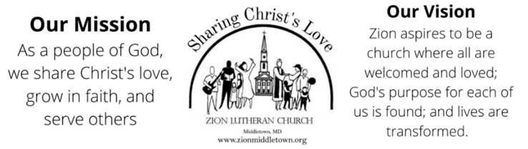
Phone: 301-371-6500; Website: www.zionmiddletown.org
For emergency pastoral care or to schedule an appointment, please call the church office
for additional information.
The Rev. Diane Day—Co-Pastor
ext. 202, pastordiane@zionmiddletown.org
The Rev. Matt Day—Co-Pastor
ext. 209, pastormatt@zionmiddletown.org
Deb Reichelt – Office Business Manager
treasurer@zionmiddletown.org
Kaye Derr-Financial Secretary
financialsecretary@zionmiddletown.org
Matt Puziss - Director Contemporary Worship Team
mattpuziss@gmail.com
Katelyn McClinton-Director of Traditional Music Ministry
katelynmcclinton@gmail.com
Kirk Denton-Organist
kirk.denton@rhosymedre.com
Emily Hopson – Children’s Choir Director
emilyfulton1031@gmail.com

