Zion Lutheran Church
9 a.m. Contemporary Worship
Twenty-Third Sunday after Pentecost
November 16, 2025

Scripture Readings
First Reading: Malachi 4:1-2a
Second Reading: 2 Thessalonians 3:6-13
Gospel Reading: Luke 21:5-19

Altar Flowers
Altar flowers are given to the Glory of God and in honor of my children, grandchildren, and great-grandchildren and in memory of my beloved husband, Carlton, by Adrienne Rhoderick

Zion Prayer List 11-16-2025
Shirley Hyssong, Ronnie Kinna, The Family of April Box, The Yonge Family, Carrie Basler, Dennis McGinnis, John Hughes, Linda Kinna-Engel, Dave Gouker, Pat McIntosh, Ron Moss, Richard Brandenburg, Ruth Brant, Vicki Ringwelski, Elsie Warnock, David Shupe, Meredith Kinna, George Engel, Jo Ahalt, Glenn Little, Sandy Bidle, Catherine Brown, Tristan Swiney, J. Richard Staples, All Government Workers, Pastor Diane Day, Beverly Smith, Dana Carmichael, Brenda Ward, The Gunsallus Family, Samn Huffer, Pat Hansen, Eric Kinna, Linda Stottlemyer, Anita, Gary, Bruce Albright, Marty Appleby, Judith Smith, Jackie Bello, Trish Tollefson, Addison Hopson, Kevin Kinna, Deb Kahihikolo

Deaths: April Box, George Yonge

Please note the updated Prayer List. If a name was removed you would like on, please let the Church Office know. Thank you! Please also be sure the church is notified if you are hospitalized and if you wish to be placed on the prayer list or would like visitation.

To give financially, please give either online or in the offering plate that the ushers will pass in between pews. You can also scan the QR code to be taken to our online giving portal.

Zion Lutheran Church
9 a.m. Contemporary Worship
Twenty-Third Sunday after Pentecost
November 16, 2025

Scripture Readings
First Reading: Malachi 4:1-2a
Second Reading: 2 Thessalonians 3:6-13
Gospel Reading: Luke 21:5-19

Altar Flowers
Altar flowers are given to the Glory of God and

Zion Prayer List 11-16-2025
Shirley Hyssong, Ronnie Kinna, The Family of April Box, The Yonge Family, Carrie Basler, Dennis McGinnis, John Hughes, Linda Kinna-Engel, Dave Gouker, Pat McIntosh, Ron Moss, Richard Brandenburg, Ruth Brant, Vicki Ringwelski, Elsie Warnock, David Shupe, Meredith Kinna, George Engel, Jo Ahalt, Glenn Little, Sandy Bidle, Catherine Brown, Tristan Swiney, J. Richard Staples, All Government Workers, Pastor Diane Day, Beverly Smith, Dana Carmichael, Brenda Ward, The Gunsallus Family, Samn Huffer, Pat Hansen, Eric Kinna, Linda Stottlemyer, Anita, Gary, Bruce Albright, Marty Appleby, Judith Smith, Jackie Bello, Trish Tollefson, Addison Hopson, Kevin Kinna, Deb Kahihikolo

Deaths: April Box, George Yonge

Please note the updated Prayer List. If a name was removed you would like on, please let the Church Office know. Thank you! Please also be sure the church is notified if you are hospitalized and if you wish to be placed on the prayer list or would like visitation.
To give financially, please give either online or in the offering plate that the ushers will pass in between pews. You can also scan the QR code to be taken to our online giving portal.

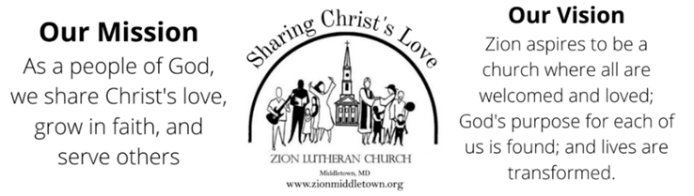
Phone: 301-371-6500; Website: www.zionmiddletown.org
For emergency pastoral care or to schedule an appointment, please call the church office
for additional information.
The Rev. Diane Day—Co-Pastor
ext. 202, pastordiane@zionmiddletown.org
The Rev. Matt Day—Co-Pastor
ext. 209, pastormatt@zionmiddletown.org
Deb Reichelt – Office Business Manager
treasurer@zionmiddletown.org
Kaye Derr-Financial Secretary
financialsecretary@zionmiddletown.org
Matt Puziss - Director Contemporary Worship Team
mattpuziss@gmail.com
Katelyn McClinton-Director of Traditional Music Ministry
katelynmcclinton@gmail.com
Kirk Denton-Organist
kirk.denton@rhosymedre.com
Emily Hopson – Children’s Choir Director
emilyfulton1031@gmail.com

Servants in God’s House
November 23, 2025
9 a.m. Contemporary Worship
Bob and Kathy Hetrick (Greeter)
Bob Hetrick (Lector)
Ike Ahalt (Head Usher)
Glenn Baker (Sanctuary Usher)
Alyssa Minchoff (Comm Asst)
Levi Derr (Power Point)
11 am (Live Stream)

Servants in God’s House
November 16, 2025
9 a.m. Contemporary Worship
Julie Thompson (Greeter)
Bre Bybel (Lector)
Eddie Main (Head Usher)
Rosella Wilson (Sanctuary Usher)
Bre Bybel (Comm Asst)
Thomas Day (Power Point)
Glenn Baker (Live Stream)

Servants in God’s House
November 23, 2025
9 a.m. Contemporary Worship
Bob and Kathy Hetrick (Greeter)
Bob Hetrick (Lector)
Ike Ahalt (Head Usher)
Glenn Baker (Sanctuary Usher)
Alyssa Minchoff (Comm Asst)
Levi Derr (Power Point)
11 am (Live Stream)

Servants in God’s House
November 16, 2025
9 a.m. Contemporary Worship
Julie Thompson (Greeter)
Bre Bybel (Lector)
Eddie Main (Head Usher)
Rosella Wilson (Sanctuary Usher)
Bre Bybel (Comm Asst)
Thomas Day (Power Point)
Glenn Baker (Live Stream)

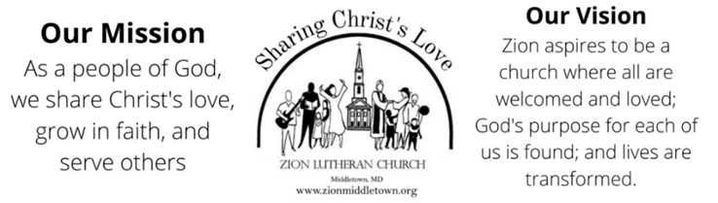
301-371-6500; Website: www.zionmiddletown.org
For emergency pastoral care or to schedule an appointment, please call the church office
for additional information.
The Rev. Diane Day—Co-Pastor
ext. 202, pastordiane@zionmiddletown.org
The Rev. Matt Day—Co-Pastor
ext. 209, pastormatt@zionmiddletown.org
Deb Reichelt – Office Business Manager
treasurer@zionmiddletown.org
Kaye Derr-Financial Secretary
financialsecretary@zionmiddletown.org
Matt Puziss - Director Contemporary Worship Team
mattpuziss@gmail.com
Katelyn McClinton-Director of Traditional Music Ministry
katelynmcclinton@gmail.com
Kirk Denton-Organist
kirk.denton@rhosymedre.com
Emily Hopson – Children’s Choir Director
emilyfulton1031@gmail.com

